Chapter 18, Problem 45.

Use Fourier transform to find i(t) in the circuit of Fig. 18.47 if 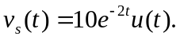

2 Ω i
+
_

v_{s}
2 Ω 1 H

Figure 18.47
For Prob. 18.45.

